Day 11:
Dataset Findings and analysis
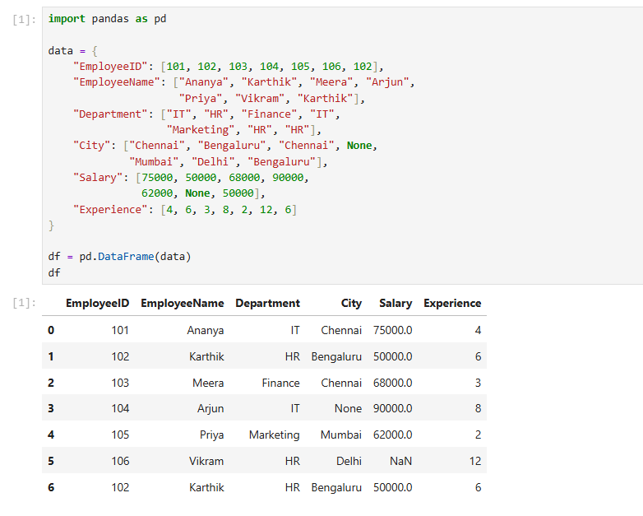

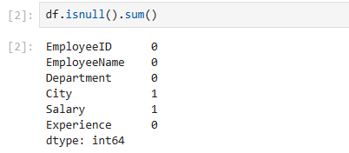
Findings:
The city column has one missing value, and the Salary column has one missing value.
- Possible causes: Incomplete employee records or errors during data import.
- Impact: Missing salaries can distort salary statistics, while missing cities affect location-based reporting.
- Business decisions: Validate employee records and fill missing values only after checking reliable HR sources.

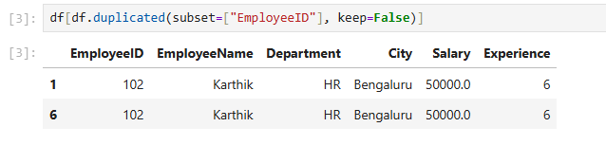
Findings:
Employee ID 102 appears twice.
- Possible causes: Duplicate data entry or repeated imports.
- Impact: Employee headcounts and department statistics may be overstated.
- Business decisions: Verify the employee records before removing duplicates, because repeated IDs can sometimes indicate conflicting records that need investigation.

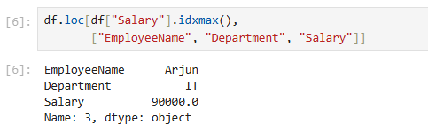

Findings:
Arjun has the highest salary of ₹90,000 in this dataset.
- Possible causes: Differences in experience, role, responsibilities, or seniority.
- Impact: Incorrect salary records can distort compensation comparisons.
- Business decisions: Use verified salary information to review pay structures and identify compensation differences across roles.

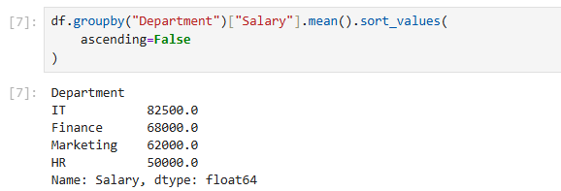

Findings:
The output shows the average recorded salary for each department.
- Possible causes of differences: Departments may have different job levels, responsibilities, and experience distributions.
- Impact: Duplicate records or missing salaries can distort departmental comparisons.
- Business decisions: Use the results to review departmental budgets and compensation patterns. Verify the data before making salary decisions.

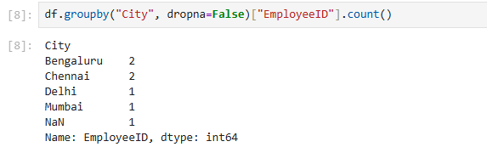

Findings:
This displays the number of employee records associated with each city, including records with missing cities.
- Possible causes: Incomplete employee profiles or employees assigned to different office locations.
- Impact: Incorrect location counts can affect office capacity planning.
- Business decisions: Use validated location data for office planning and resource allocation.

